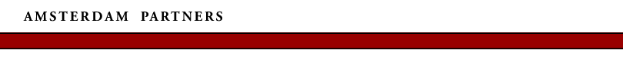
THE NETHERLANDS IS BEST PLACE IN THE WORLD FOR BUSINESS

The Netherlands will be the best place in the world to do business over the next five years (2003-2007), according to the latest rankings published by the Economist Intelligence Unit (EIU). This is the fifth consecutive year that the Netherlands has received the top ranking. The Netherlands scored particularly high on political stability and effectiveness, foreign investment policy and availability of finance. Following the Netherlands, the top five includes Canada, Finland, the United Kingdom and the United States of America.
The Netherlands ranked equal 3rd in the EIU’s 2003 ‘E-readiness’ report on the world’s 60 largest economies, an essential benchmark for multinationals wanting to invest in technologically innovative countries. On a 10-point scale, the Netherlands improved marginally on last year’s overall score to 8.43.
Amsterdam’s advanced IT infrastructure is a major reason for international IT giants such as Cisco Systems, as well as smaller innovative IT companies, to set up their European headquarters here. On a local scale, the Dutch capital has a high penetration of Internet connectivity, and one of the City Council’s priorities is a fibre-optic cable connection to every household.

http://www.eiu.com/

